**WEEK 5: MANDATORY HANDS-ON**

**Microservices with API gateway**

**Creating Microservices for account and loan**

Solution:

**1.Account Microservices**

Create a controller class like:

package com.cognizant.account.controller;

import org.springframework.web.bind.annotation.*;

@RestController

@RequestMapping("/accounts")

public class AccountController {

@GetMapping("/{number}")

public Account getAccount(@PathVariable String number) {

return new Account("00987987973432", "savings", 234343);

}

static class Account {

private String number;

private String type;

private int balance;

public Account(String number, String type, int balance) {

this.number = number;

this.type = type;

this.balance = balance;

}

public String getNumber() { return number; }

public String getType() { return type; }

public int getBalance() { return balance; }

}

}

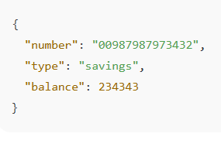

**2.Loan Microservice**

package com.cognizant.loan.controller;

import org.springframework.web.bind.annotation.*;

@RestController

@RequestMapping("/loans")

public class LoanController {

@GetMapping("/{number}")

public Loan getLoan(@PathVariable String number) {

return new Loan("H00987987972342", "car", 400000, 3258, 18);

}

static class Loan {

private String number;

private String type;

private int loan;

private int emi;

private int tenure;

public Loan(String number, String type, int loan, int emi, int tenure) {

this.number = number;

this.type = type;

this.loan = loan;

this.emi = emi;

this.tenure = tenure;

}

public String getNumber() { return number; }

public String getType() { return type; public int getLoan() { return loan; }

public int getEmi() { return emi; }

public int getTenure() { return tenure; }

 